Flink IDEA开发环境部署

1.1创建maven工程

file-new-project-Maven

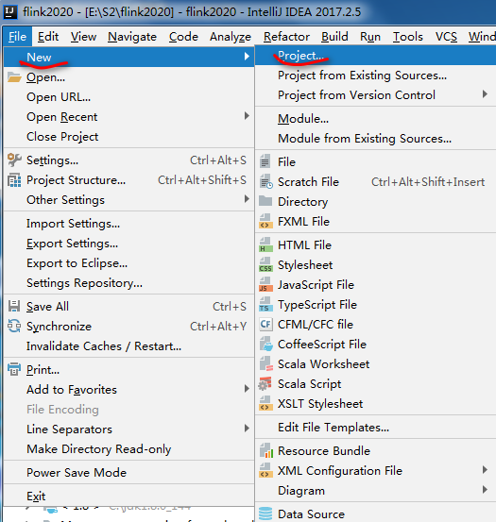

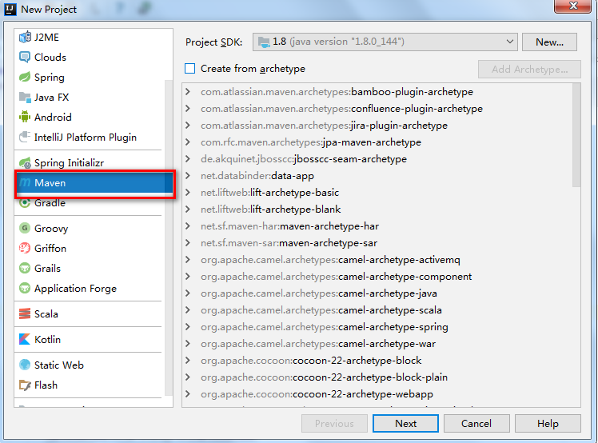

(2) 设置GroupId和ArtifacId：

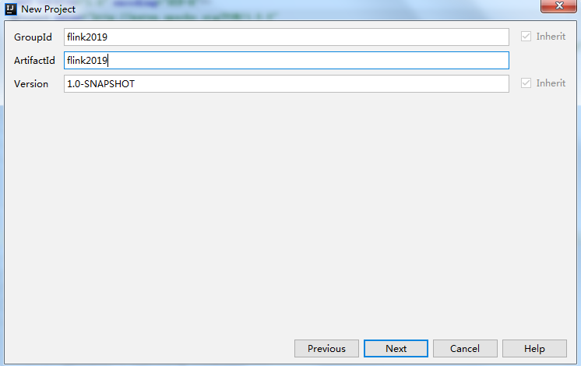

设置存储路径

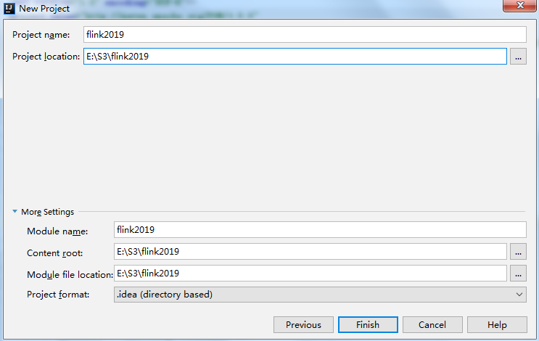

Finish完成

1.2 配置maven

选择自动更新

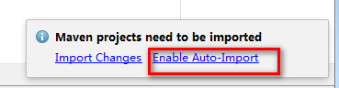

配置pom.xml

添加依赖

<dependencies>

<dependency>

<groupId>org.apache.flink</groupId>

<artifactId>flink-java</artifactId>

<version>1.7.2</version>

<scope>provided</scope>

</dependency>

<dependency>

<groupId>org.apache.flink</groupId>

<artifactId>flink-streaming-java_2.11</artifactId>

<version>1.7.2</version>

<scope>provided</scope>

</dependency>

<dependency>

<groupId>org.apache.flink</groupId>

<artifactId>flink-scala_2.11</artifactId>

<version>1.7.2</version>

<scope>provided</scope>

</dependency>

<dependency>

<groupId>org.apache.flink</groupId>

<artifactId>flink-streaming-scala_2.11</artifactId>

<version>1.7.2</version>

<scope>provided</scope>

</dependency>

</dependencies>

<build>

<plugins>

<plugin>

<groupId>org.apache.maven.plugins</groupId>

<artifactId>maven-shade-plugin</artifactId>

<version>3.1.1</version>

<executions>

<execution>

<phase>package</phase>

<goals>

<goal>shade</goal>

</goals>

<configuration>

<artifactSet>

<excludes>

<exclude>com.google.code.findbugs:jsr305</exclude>

<exclude>org.slf4j:*</exclude>

<exclude>log4j:*</exclude>

</excludes>

</artifactSet>

<filters>

<filter>

<!-- Do not copy the signatures in the META-INF folder.

Otherwise, this might cause SecurityExceptions when using the JAR. -->

<artifact>*:*</artifact>

<excludes>

<exclude>META-INF/*.SF</exclude>

<exclude>META-INF/*.DSA</exclude>

<exclude>META-INF/*.RSA</exclude>

</excludes>

</filter>

</filters>

<transformers>

<transformer implementation="org.apache.maven.plugins.shade.resource.ManifestResourceTransformer">

<mainClass>my.programs.main.clazz</mainClass>

</transformer>

</transformers>

</configuration>

</execution>

</executions>

</plugin>

</plugins>

</build>

1.3 修改jdk版本

（1）

File-Setting-Build,Execution,Deployment--Compiler-Java Compiler

把红框中的两项都修改为jdk1.8

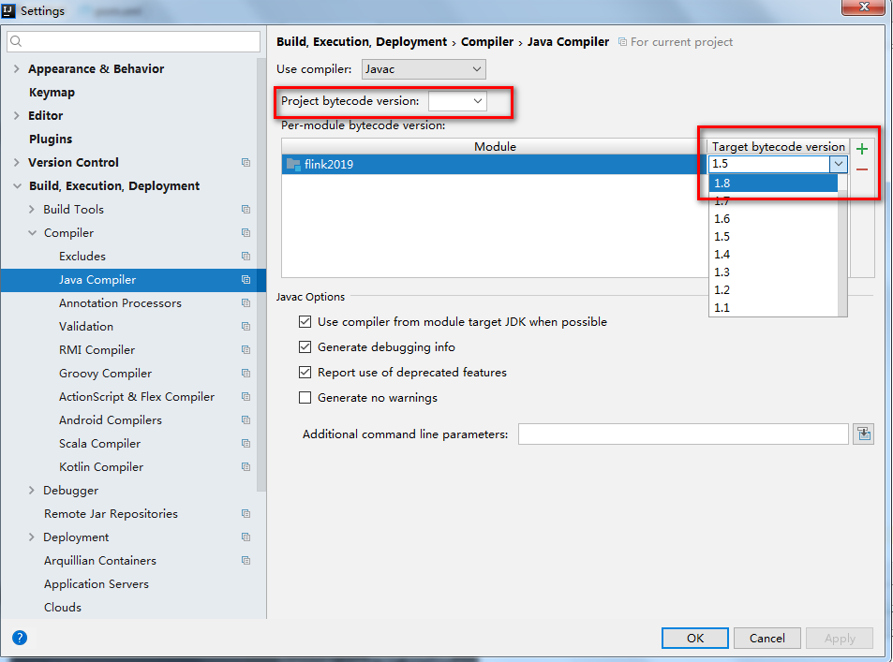

（2）

File-Project Structure-Module

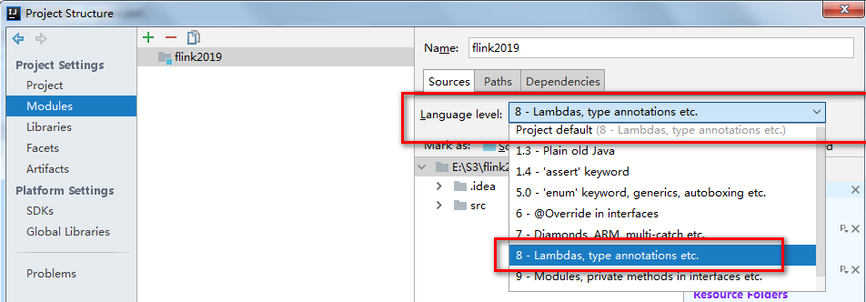

(3)

File-Project Structure-Project Settings--Project-Project language level

